MSSV: DTH225710
Họ và tên: LÊ TRÍ NHÀN
Lớp: DH23TH2
Ngày thực hiện: 30/12/2025

Creating a Blockchain Network
Description
You are an employee of Simplilearn and have been asked to create a Blockchain network to demonstrate the working of Blockchain.
The objective of this project is to demonstrate the working of a Blockchain network.
Domain: Education Services
Goals of the project:
You need to perform the following steps to complete the project:
Visit https://blockchaindemo.io/ and create blocks for the existing peer
Create another peer and blocks for the same
Connect the newly created peer with the existing peer
Note: This is a practice project and does not contribute to course completion.

Lesson-End Project : Blockchain Network
Problem Statement: You are an employee of Simplilearn and have been asked to create a Blockchain network to demonstrate the working of Blockchain.
Steps to Perform:
Step 1: Visit https://blockchaindemo.io/ and create blocks for the existing peer. Enter data in the data field, and click Add New Block.
Step 2: Create another peer and blocks.
  - Click on Add Peer button to add a new peer
  - Select the new peer created
  - Enter data in the data field (MSSV – Họ và tên – Lớp), and click Add New Block to add blocks to the new peer
Step 3: Connect the newly created peer by clicking on the connect symbol.
Step 4: Similarly, add peers and blocks and create a Blockchain network.

CHỤP HÌNH KẾT QUẢ TỪNG BƯỚC VÀ GIẢI THÍCH KẾT QUẢ
Bước | Ảnh | Giải thích
STEP1 | 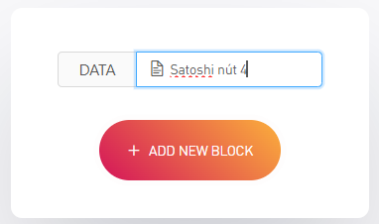  1. nhập dữ liệu  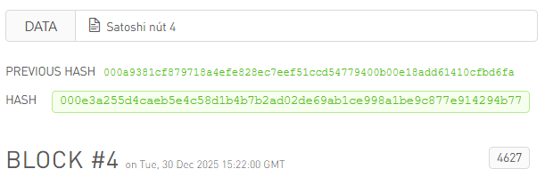  2. hệ thống tạo ra 1 nút mới từ dữ liệu vừa nhập | Khởi tạo dữ liệu cho nút có sẵn để hệ thống tính toán mã Hash đầu tiên và tạo ra khối (block) trong chuỗi
STEP2 | 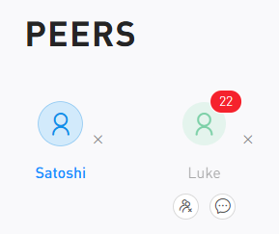 | Tạo thêm một nút (Peer) mới để mô phỏng tính chất phi tập trung, nơi mỗi máy tham gia đều giữ một bản sao của sổ cái
STEP3 | 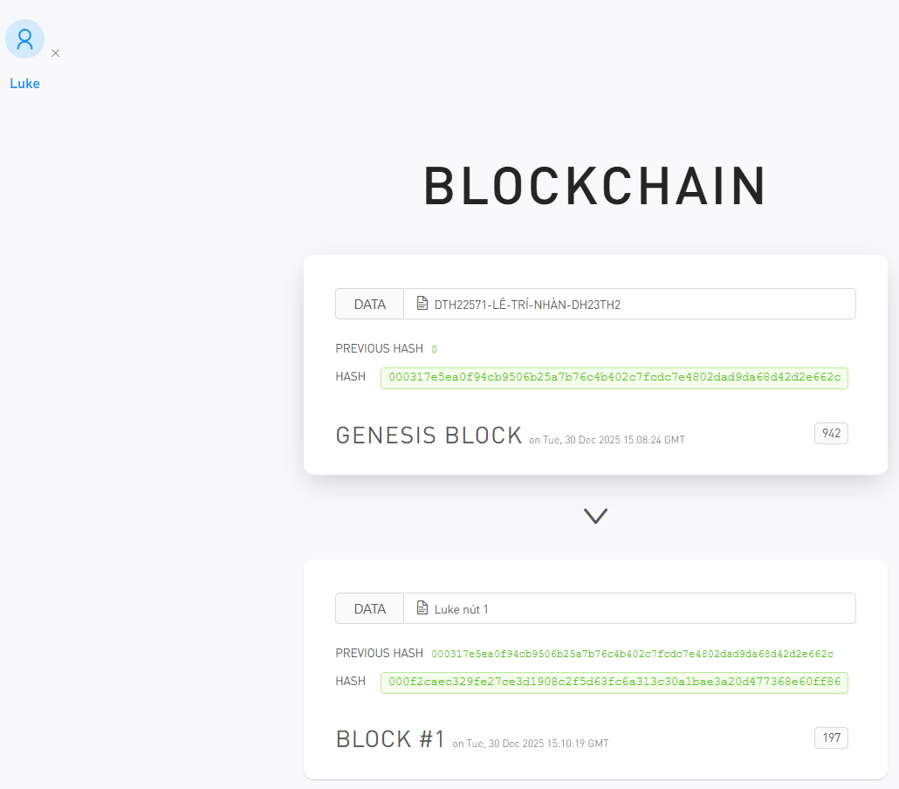 | Nhập thông tin định danh cá nhân vào nút mới để tạo ra một khối dữ liệu riêng biệt cho người dùng đó
STEP4 | 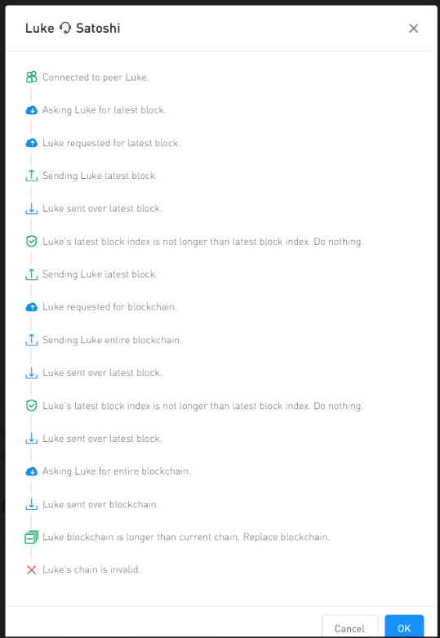 | Kết nối các nút lại với nhau để kích hoạt cơ chế đồng thuận, giúp các máy máy tính trong mạng lưới đồng bộ dữ liệu giống hệt nhau.

Generate a Bitcoin Wallet
Description
You are an employee of Simplilearn and have been asked to create a Bitcoin wallet for the company to receive payments in Bitcoins for the courses purchased by the learners.
Domain: IT
The objective of this project is to create a Bitcoin wallet and generate multiple Bitcoin addresses to receive bitcoins as a payment.
Goals of the project:
You need to perform the following steps to complete the project:
Generate a single wallet
Generate a paper wallet with a passphrase
Check wallet details
Note: This is a practice project and does not contribute to course completion.

Lesson-End Project: Generate a Bitcoin Wallet
Problem Statement: You are an employee of Simplilearn and have been asked to create a Bitcoin wallet for the company. You must perform the following actions:
- Generate a single wallet
- Generate a paper wallet with a passphrase
- Check wallet details
Steps to Perform:
Step 1: Visit https://www.bitaddress.org/
Step 2: Hover over the web page to generate a Bitcoin wallet address
Step 3: Generate a single wallet
Step 4: Generate a paper wallet with a passphrase and download it
Step 5: Check wallet details by inserting the private key of the single wallet

CHỤP HÌNH KẾT QUẢ TỪNG BƯỚC VÀ GIẢI THÍCH KẾT QUẢ
Bước | ảnh | Giải thích
STEP 2-3 | 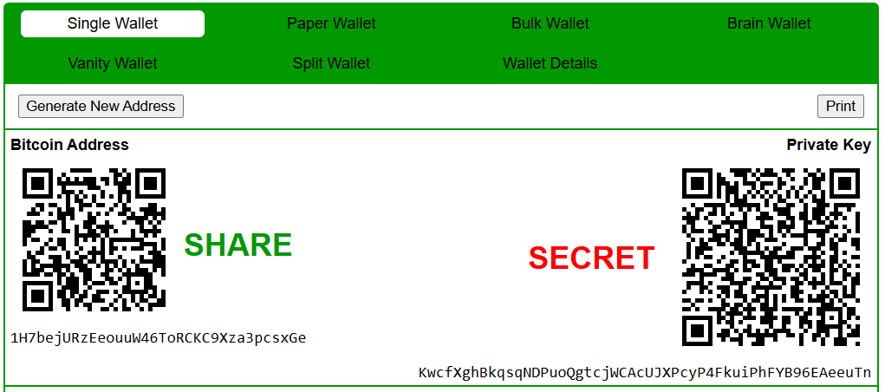 | Tạo sự ngẫu nhiên (entropy) bằng hành động di chuyển chuột để đảm bảo khóa bí mật được tạo ra là duy nhất và không thể bị đoán trước.  Tạo ví đơn để xác định cặp địa chỉ: "Địa chỉ nhận tiền" (công khai) và "Khóa bí mật" (để chi tiêu).
STEP4 | 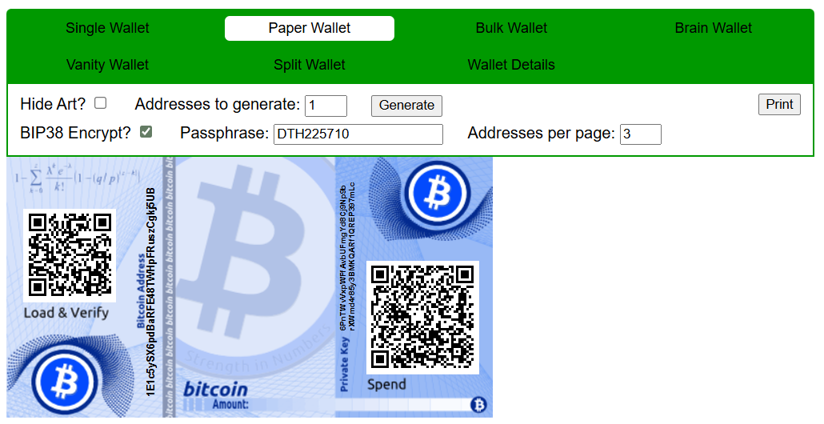 | Tạo ví giấy có mật khẩu giúp lưu trữ tài sản ngoại tuyến (ví lạnh), tăng cường bảo mật chống lại hacker mạng

Transfer Bonus Using MetaMask
Description
You are an employee of Simplilearn and have been asked to transfer 100 Ethers from Simplilearn account to your personal account as a part of your performance bonus.
The objective of this project is to use MetaMask for distributing performance bonus to the employees.
Domain: Education Services
Goals of the project:
You need to perform the following steps to complete the project:
Create two accounts, one Simplilearn account and the other one as your personal account. Connect both with Ganache
Transfer 100 ETH from Simplilearn account to your account
Note: This is a practice project and does not contribute to course completion.

Lesson-End Project: Transferring Ethers Using MetaMask
Problem Statement: You are an employee of Simplilearn and have been asked to transfer 100 Ethers from Simplilearn’s account to your personal account as a part of your performance bonus.
Steps to Perform:
Step 1: Go to Google Chrome, and search for MetaMask in extensions
Step 2: Click continue on Ganache welcome screen (unique account image will be generated)
Step 3: Click next
Step 4: Read the terms to be used, and click accept
Step 5: Read the privacy note, and click accept
Step 6: Read the phishing warning, and click accept
Step 7: Reveal the secret code, and click next (Please note down the secret code)
Step 8: Create an account, say, MyAccount
Step 9: Log in to the account to check the balance (you see the balance is 0)
Step 10: In Ganache, click on settings and change the port number to 8545 and restart the Ganache
Step 11: Now, open Ganache and copy the private key to create a Simplilearn account, and link it with MetaMask
Step 12: Click on the key symbol on the right corner to get the private key of the account
Step 13: Use the primary key that you got from Ganache to create the Simplilearn account so that Ganache is linked with MetaMask and the same account can be used in MetaMask
Step 14: Now, you see the balance in Simplilearn account is 100 ETHs. Try sending 100 ETHs from Simplilearn’s account to MyAccount
Step 15: Click send and confirm
Step 16: You see that there is a deduction of 100 ETHs from Simplilearn’s account and addition of 100 ETHs to MyAccount, which is also reflected in Ganache (This indicates successful transaction of Ether and connection of MetaMask with Ganache)

CHỤP HÌNH KẾT QUẢ TỪNG BƯỚC VÀ GIẢI THÍCH KẾT QUẢ

